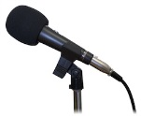
Barnes Farm Radio Presenter Application
Applications are due in by Friday 15th April. Successful applicants will receive additional training.
Your name: Class:
What are your ideas for a show and why?

Who would you involve in the show and why? (Co-presenters/guests etc)

Can you write some examples of questions you might ask?

Any other ideas?

Why should you be selected to be one of our Barnes Farm DJs?

