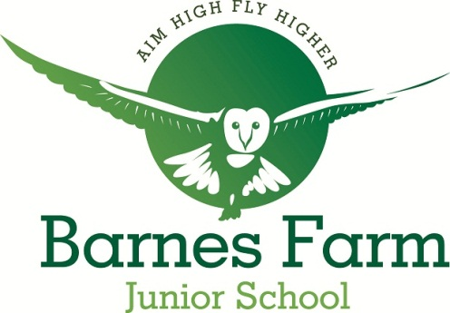
Barnes Farm Junior School

Henniker Gate, Chelmer Village,

Essex CM2 6QH

Head Teacher: Mr R McTaggart

Tel: 01245 467973

Fax: 01245 461947

E-mail

:
admin@barnesfarm-jun.essex.sch.uk

Website: www.barnesfarmjuniors.co.uk

12th March 2021
Dear Y6 Parent/Carer,

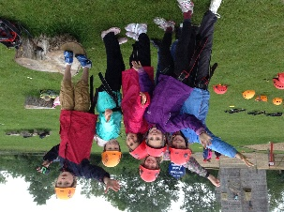
The Senior Leadership Team and Governors have been reviewing the planned Y6 residential to Mersea – planned for Monday 12th to Friday 16th July 2021.

Despite the fact that residential visits are not currently permitted, there is a pathway planned by the Government which potentially means that this visit can still go ahead in July 2021.
We are acutely aware that your children did not have the opportunity to experience a residential visit last year either.

Therefore, we are continuing to plan to attend and organise this residential. If you have not done so already, please pay your £40 deposit by Thursday 1st April 2021. We need this deposit paid to plan the trip accordingly. In the event that this trip is cancelled due to continuing covid restrictions, a full refund will be issued.

Please find some of the key details previously shared below:

The cost will be £291 which includes food, accommodation (under canvas), all activities and travel to and from the centre. We require a £40 deposit from you by Friday 6th November 2020 in order to make an initial booking and the balance of £251 to be paid by Friday 30th April 2021. In the event that the visit cannot take place due to Covid restrictions, a full refund will be made.

Full payment can also be made any time if you would prefer. All payments must be made via ParentPay as no cash will be accepted at the school office. There is a subsidised payment for those pupils who have been previously or are currently in receipt of Free School meals and we will correspond individually with those particular parents.

There may be the opportunity for a few parents to assist the Mersea visit by supervising. If you are willing to commit to accompanying the children, please comment on Parentpay when you pay your deposit.

We are unable to host an information evening at school this year, however we will be holding a virtual presentation on Wednesday 7th October at 7pm via Microsoft Teams. This will involve a presentation as well as the opportunity to ask questions via the chat function. An invitation to this will be sent out separately. If you cannot make this event, the presentation and any key questions will be uploaded onto the Y6 section of our website.

Yours Sincerely,

Ross McTaggart
Headteacher

