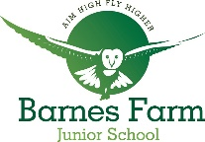
Barnes Farm Junior Sponsored Run

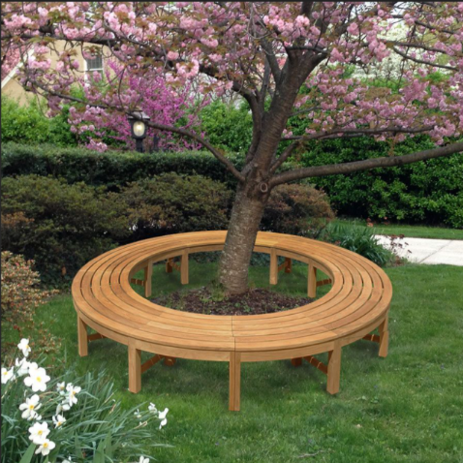
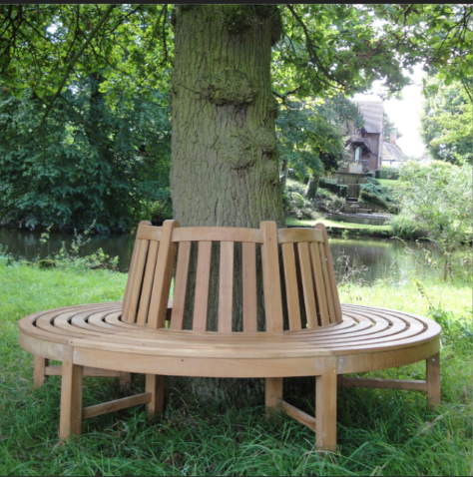
We are raising money to purchase a new circular bench for Daniel’s tree.
Children have half an hour, running laps of the Daily Mile track. Six laps = 1 mile.
Child’s Name:

I’m ‘aiming high’ to complete laps

I completed laps in half an hour.
Thank you!
Sponsor Name | Sponsorship choice
 | Per lap | Per mile | Fixed amount

Total Collected:

