YEAR 6 POP UP SHOP – ONE DAY ONLY

Throughout this half term, Year 6 have been busy working on an Enterprise Project. They have learnt what it takes to be an entrepreneur and were lucky enough to have local entrepreneurs speak to them about their businesses and provide words of wisdom at the start of the project. The pupils have developed a variety of skills, including teamwork, Art and Design (inventing, making, and refining products to sell), English (advertising their product using persuasive techniques) and Maths (conducting market research and calculating costs and profit).
Year 6 are very excited to give pupils from Year 3, 4 and 5 the opportunity to buy the items they have spent the past few weeks carefully designing and making. We will be holding our enterprise sale next week on Thursday 1st July where each class will be able to view and choose products to purchase. Pupils will need to bring in cash, preferably coins, on Thursday 1st July if they wish to buy any items from the Year 6 sale. Prices will range from 50p to £3; most products will be priced at £1, including bookmarks, slime, keyrings, stress balls, scrunchies and gliders. Please keep your eyes peeled for posters around the school with further details about the products Year 6 are selling.
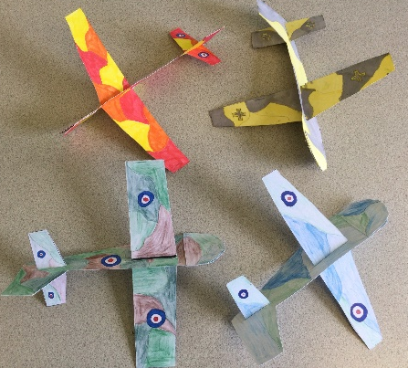
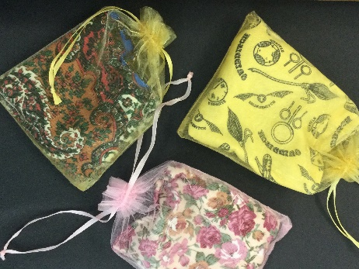
We hope to use any profits made to go towards a special treat for the Year 6 pupils to thank them for all their hard work and celebrate their achievements before they leave Barnes Farm Junior School.
