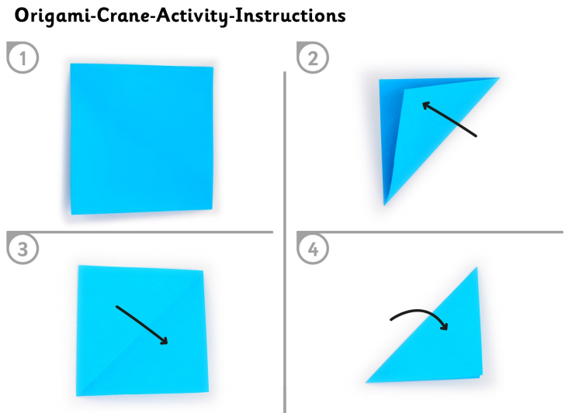
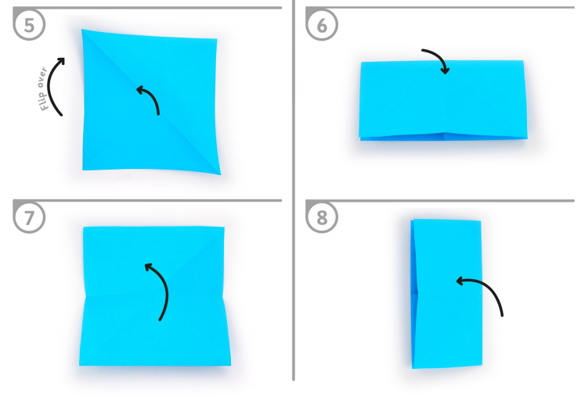
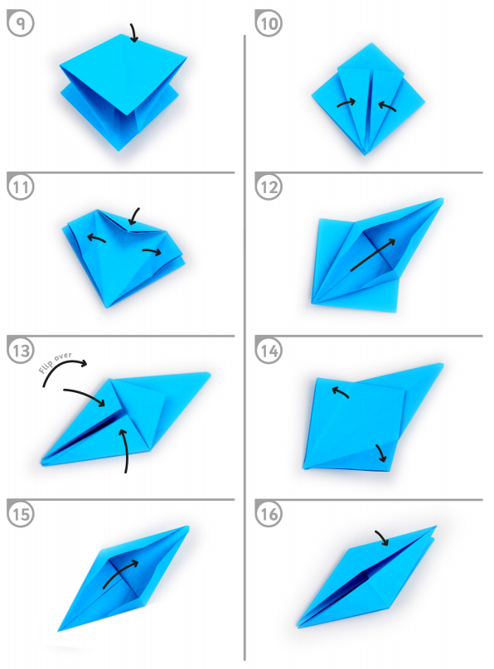
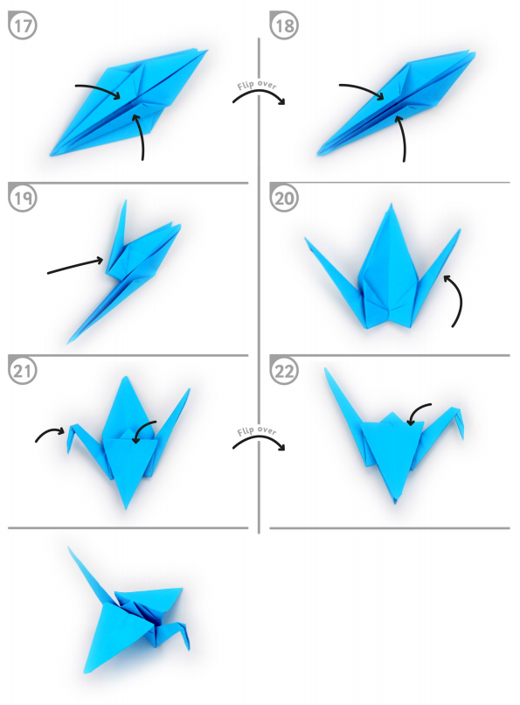
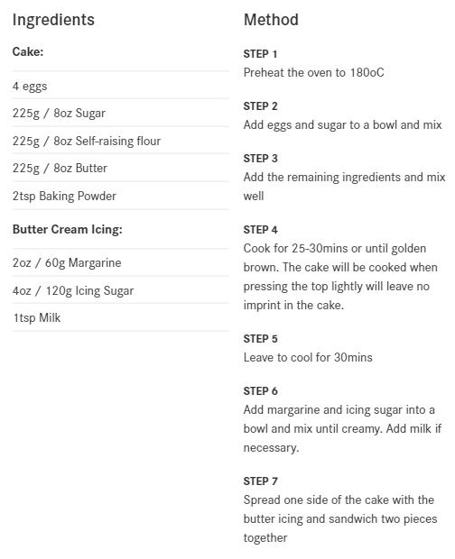
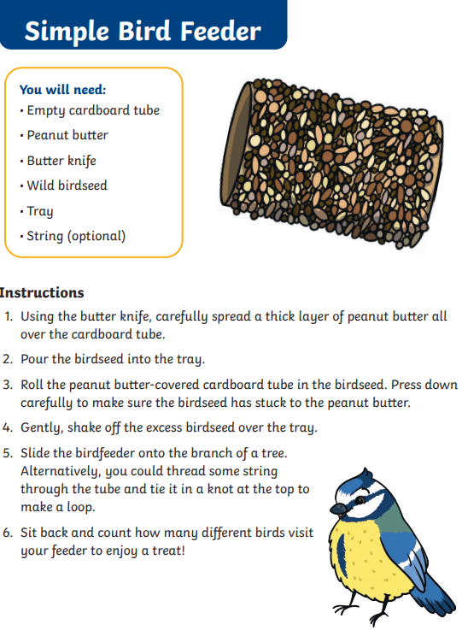
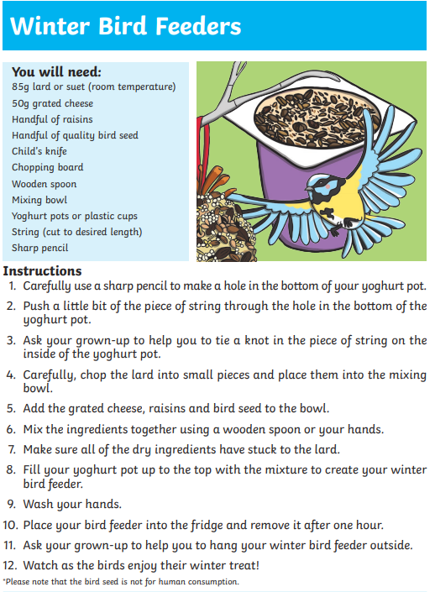
Card Tricks

Red And Black
Before you do this trick, separate the cards, putting all the black cards at the top of the deck and all the red cards at the bottom.
- Fan the cards out, face down, and ask your audience member to pick a card. Mentally note whether it came from the red or the black area of the deck.
- Tell them to look at their card, remember it, and place it back in the pile.
- Before they put the card back, fan the cards again so that the audience member puts the card back in the opposite end of the pack from where they drew the card.
- Fan out the cards with the faces toward you and the audience member’s card will be the one in the wrong colour.

Guess The Bottom Card
Show the cards to your audience so they can see it is a normal deck.
- Shuffle the cards or give them to an audience member to shuffle.
- Take the deck and glance at the bottom card before you hold the entire deck face down in your left hand.
- Using your left hand, start to move the cards at the top of the deck toward you, and ask your audience member to say stop whenever they like.
Now comes the tricky bit. You will have to practice this to make it go smoothly.
- When they say stop, slide the top cards off of the deck and slide the bottom card off at the same time. You should now have a small pile in your right hand, with the bottom card you remember, at the bottom of this new, small pile.
- Place this small pile at the bottom of the main deck. Your card should still be at the bottom. Do this a few times so the audience believes the cards are well mixed.
- Close your eyes, for dramatic effect, and slide the card from the bottom of the deck. Hold it so it faces the audience.
- Ask your audience “Is this the…….?” and name the card.

The Fourth Card
No set-up is required for this trick.
- Shuffle and pass the deck to an audience member. Let them shuffle and cut the deck as much as they like.
- When the audience member indicates the cards are well mixed, flip the deck over, and fan them out. Do this quickly and smoothly so it looks as if you are just showing the cards. However, what you are really doing is looking at the fourth card from the top, the “Target Card.”
- Place the deck, face down, on the table.
- Ask the audience member to cut the cards anywhere they like. Tell them to place the pile in their hand down on the table next to the other pile.
- Remember which pile was the top of the deck. We will call this the “Top Pile.”
- Now pick up the bottom pile and tell the audience, “The fourth card in this pile is going to tell me what the fourth card in the other pile is.”
- Count down to the fourth card and look at it. Do not let the audience see this card, but they can see you looking at it.
- Say “This card tells me the fourth card in this pile is” and point to the “Top Pile” with a dramatic pause.
- Say the name of the “Target Card” you saw at the beginning of the trick.
- Now count down four cards, flip over the fourth card, and it will be your “Target Card.”

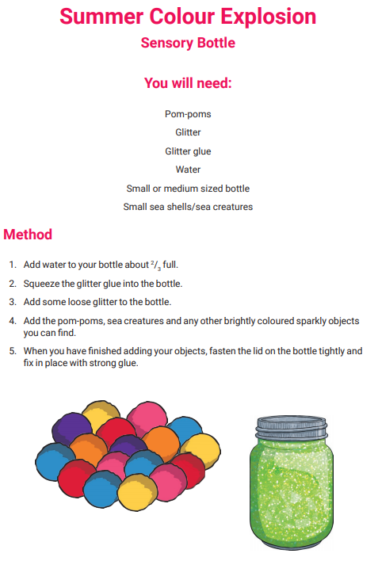
NB. Also works with oil e.g. baby oil instead of glitter glue.
