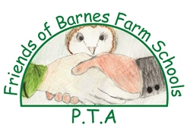
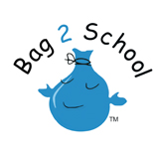
www.bag2school.com

We are pleased to announce that the Friends of Barnes Farm Schools has organised another textile collection with Bag2School in order to raise funds for both the schools
Bag2School collection has been arranged for

Friday 15th April 2016

So please start saving up your old clothes for the collection. Bags will be given out nearer the collection date.
Accepted: | Not accepted:
Men’s, Ladies and Children’s clothing | Duvets, bedding, blankets and household linen
Paired shoes (tied together or elastic band around) | Pillows and cushions
Handbags | Carpets, rugs and mats (including bath, shower and toilet mats)
Hats | Curtains
Bags | Towels
Scarves and ties | Soiled, painted, ripped or wet clothing*
Jewellery | School uniforms (logo stuff can be donated to PTA secondhand school sales instead!)
Lingerie | Corporate clothing and workwear
Belts | Textile off cuts, yarns or threaded material
Soft toys
Further details to follow, any questions please contact chairFOBFS@yahoo.com

