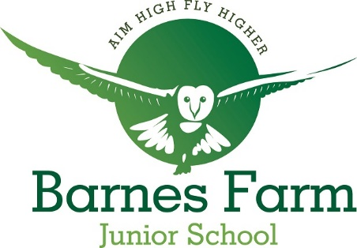
Barnes Farm Junior School
NOMINATION FORM FOR THE ELECTION OF PARENT GOVERNOR
Name:
Address:
Telephone:
Pen Portrait (maximum 50 words)

I wish to submit my nomination for the election of Parent Governor.
I confirm the following:
- that I am willing to stand as a candidate for election as a parent governor
- that I am not disqualified from holding office for any of the reasons set out in the School Governance Regulations.

Signature ………………………………………………………………………..
(Date) ………………………………………………………………………….

Completed nomination forms must be returned to the school by Monday 11th October 2021

