Star of the Week!
Katherine Grainger
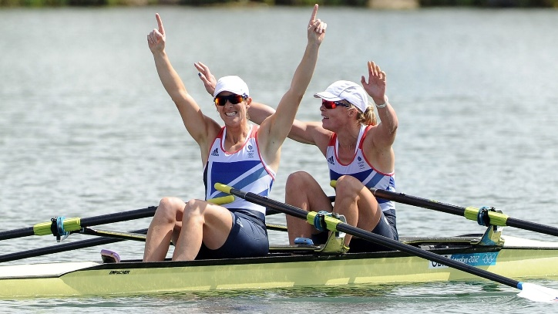

Dame Katherine Jane Grainger DBE (born 12th November 1975) is a British former rower who was born and raised in Aberdeenshire in Scotland. With five Olympic medals, Grainger is Great Britain's most decorated female Olympian and most recently, won a silver medal in the Rio 2016 Olympic Games. At the London Olympics 2012, Anna Watkins and Katherine Grainger broke the Olympic record as they qualified for the double sculls final, before winning the gold medal!
Creative Challenge: Draw your favourite Olympian and the sport they do. Write a description about their achievements.

Research Challenge: We know who is Great Britain’s most decorated female Olympian is but who is the most decorated male Olympian?

Physical Challenge: Whole body fitness is really important when rowing. Try improving your whole body fitness through doing a different activity each day

NATIONAL SPORTS WEEK 20th June – 26th June
In celebration of National School Sports Week we are hoping that all children, whether at home or school, will be able to take part in the following:
- KS1, LKS2 OR UKS2 Virtual Quad kids (althetics) Competition.
- A daily challenge from the Youth Sport Trust or Active Essex or Yorkshire Tea National Cricket Week.
Youth Sport Trust Activities
We may be apart right now but sport has the power to unite us. During National School Sport Week at home, your family can challenge your neighbours or family and friends to virtual sporting competitions, helping us all feel connected.
National School Sport week is run by the Youth Sports Trust and Sky Sports in the hope to unite the Country with sport at home (and school) . This is an annual event to celebrate the important role of Physical Education and school sport in enhancing young people’s wellbeing.
Hopefully you have registered with the Youth Sport Trust and have received videos and activity cards to help you do your challenges over the week. http://bit.ly/YSTNSSW The activities have an emphasis on togetherness, inclusivity and wellbeing. You can share your challenges online during the week using the hashtag #NSSWtogether
Active Essex Activities
Active Essex are supporting National School Sport Week running daily challenges with videos, please click on the attached link to see the activities. Try and do one each day. Click on the link to see the fun challenges.
Active Essex
MONDAY 22ND JUNE -parents v kids toe tap!
TUESDAY 23RD JUNE -Sitting volleyball challenge
WEDNESDAY 24TH JUNE -Juggling Challenge
THURSDAY 25TH JUNE -Zumba Challenge
FRIDAY 26TH - Fitness challenge parents V kids!

https://bit.ly/NSSWEssex

Yorkshire Tea National School Cricket Activities
This is an opportunity to celebrate the sport, to inspire children to take part in cricketing activities and to showcase the work that Chance to Shine does in bringing the game to hundreds of thousands of children every year. Chance to shine have produced videos and activities for your children to do. Click on www.ecb.co.uk/play/all-stars. or https://www.chancetoshine.org/Blogs/national-cricket-week-2020 Next week follow Yorkshire Tea on social media to see all that is going on. 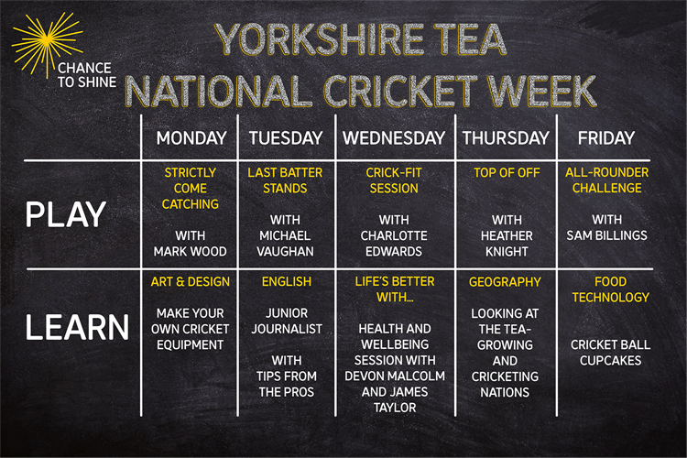
Chelmsford SSP Virtual Quad Kids Competition
To celebrate National School Sport Week we are holding a virtual Competition for all children called Quad Kids. We hope you can help them complete it.
Would your child like to represent their school in Quad Kids? If yes, simply set up the four activities for them to complete and record their results and send the scores into your school. Each school will collate the scores and send their top results into us at the Chelmsford School Sport Partnership.
You have three weeks to complete the activities and the results will be announced on 13th July. Medals for the winning team and certificates for all who take part.
The quad kids instructions and score sheets can be found on the website https://www.chelmsfordssp.com/parent-zone/ or attached to this email.
Below are the simple instructions for the four events.
Sprint
A simple straight line sprint.
Years : EYFS, 1,2,3,4 50m sprint
Years : 5 and 6 75m sprint

If you don’t have access to an area big enough to complete in a straight line you can make up the distance in shuttle runs.
Jump
The jump for Quad Kids is a standing long jump.
Make a line to jump from, put your toes right up to the line, bend low and swing your arms. Jump as far as you can. You must measure from the nearest point to the start line (see below).
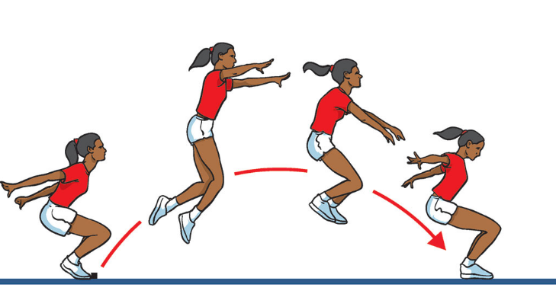

Bounce
We want to see how many speed bounces you can do in 20 seconds. A speed bounce is a 2 footed jump from side to side over a low barrier. They only count if they are a 2 feet to 2 feet jump.

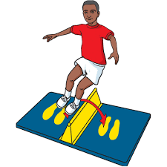
Throw
We would like you to measure a tennis ball throw from a standing position (No run ups allowed). Measure in meters and centimetres from the throwing line to where the ball first touches the ground and not where it rolls too.
When you have done the events look at the conversion sheet and give each result a score. When you have all four scores you can send it into your class teacher.

More Fun Activities :
Colouring Competition for designing a Cycling shirt – https://www.chelmsfordssp.com/parent-zone/ Happy Healthy Ideas
Boccia Paralympic colouring activity
https://www.chelmsfordssp.com/parent-zone/ Happy Healthy ideas

Physical Challenges - Video challenges of simple activities https://www.chelmsfordssp.com/parent-zone/ physical challenges

Please find certificates on Chelmsford SSP for all children taking part in National School Sport Week. https://www.chelmsfordssp.com/parent-zone/ Happy Healthy Ideas

Have a good week everyone.

